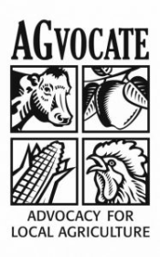
Hampton Agricultural Commission
Regular Meeting and Calendar Meeting
Thursday, November 21,, 2019
Hampton Town Hall
7:00 pm

Open Regular Meeting / Roll Call
Audience for Citizens
Approval of Minutes
Old Business
New Business
Calendar Decisions
General Discussion
Citizen Comments
Adjournment

