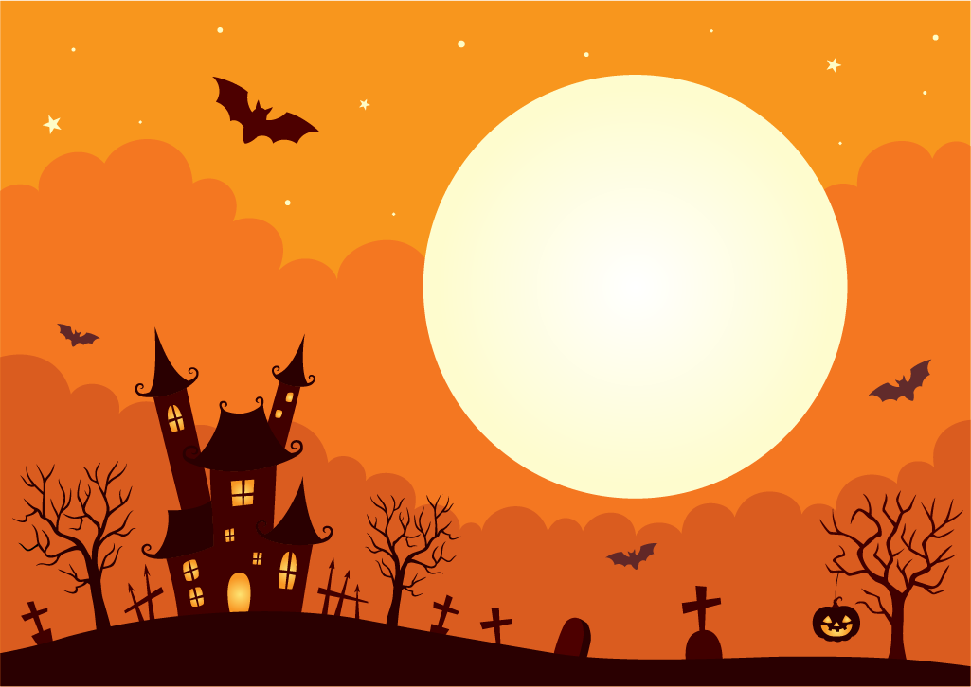
Prepare to be enchanted! The Halloween fortune-telling witch makes her grand return to HAMPTON! Children young and old will be mesmerized as she distributes her mystical pennies and reveals intriguing predictions about their futures!
The Recreation Commission will be hosting this magical event!
Where: The Pavilion next to the town hall on Main Street
When: Thursday, October 31st from 5 to 7 pm!

Be sure to visit the Witch and receive a goodie bag filled with treats and prizes!!

