Hampton Conservation Commission
Regular Meeting Wednesday October 18, 2023 6:30 PM Town Hall Meeting Room
MINUTES

Call to order: The meeting was called to order at 6:30 PM by Chair Mark Samios. Members present: Marcia Kilpatrick, Penny Newbury, Stan Crawford (seated for Bruce Spaman), Kevin Grindle. Absent: Marc Cardwell, Ev Hyde, Bruce Spaman. Audience members present: John Tillinghast, Selectman, Sue Hochstetter.

New Business/Presentation moved to the beginning of the meeting:
Tanner Steeves from DEEP gave a presentation on a project the DEEP is doing near the Little River by Sand Hill Rd: “forestry mowing” on 6 acres. A 7-10 day project designed to create some “new forest” habitat in a fairly invasive-rich area. The mower will be TR Landworks (Ted). The goal is to get 10% new growth habitat in a parcel.
He then looked at our LRP map to identify the areas of interest that might be helpful on our next application: different habitats, river, wet meadow, riparian area, wet forest, upland forest, hayfields.

Audience for citizens: Susan H. thanked the HCC for the work done on the Walktober event at the LRP.

Approval of Minutes of Previous Meeting (9/20/23)
Motion made and seconded (Marcia/Stan) to approve the minutes. Approved.

Old Business
Little River Updates
- Kevin discussed the next round of grant funding for Recreational Trails: open in November, with a close date of March. $10million this time. He recommended that we get DEEP to visit the LRP. Kevin will have some conversations with the greenways, Trails, and Wildlife commissions to discuss our recreational trails plans.
- Letters of support need to be re-dated and re-signed.
- Kevin will ask John G. to apply to the Natural Diversity Database people to find out the species at the preserve.
- Parking lot needs to be finished so it can become part of the match.
- Stan will find out the properties between the LRP and Goodwin and try to get something in writing from they saying that the forest is close and there’s a short walk or bike ride to the LRP (for connectivity).
- We need to develop a way to describe the connections—from pollinators paths to wildlife corridors of other types, not just footpaths.

Harvest Festival Recap:
Mark reported that they received some new emails, which should be added to our email list to publicize our events, workshops, volunteer activities, etc.

Walktober Walk Recap:
It was well attended, but there was not much historical information, as was promoted.

New Business

STEAP Grant:
Denied

Knotweed Update:
Kenyon Rd is done, Parker Rd is done; needs to be seeded with wildflowers. Marcia recommended we do a Stilt Grass Wanted poster, and discussed hydrilla, which is taking over the CT river.

Pollinator Pathways
There is now a Hampton town page on the CT Pollinator Pathway website. WE will add the pollinator field behind the Community Center and the milkweed field at the LRP. It was suggested that Bruce do trees at the Edwards Preserve and Marcia will ask Trailwood to put something on the page.

Trails Symposium
Kevin reported on it: lots of focus on inclusivity, outreach, getting the public involved. “Don’t assume that people know how to experience the outdoors.”

Milkweed vs. Ag use:
Mark led a brief discussion on the milkweed at the LRP.

Budget:
Mark reported there’s still money in our budget and we need to spend it. Interpretive and other signs need to be designed/purchased. Discussion re: fencing for the parking lot, and filling in of a ditch by the road with the parking lot berm material that was dug out. HCC offered to pay for the fencing (short 10x10 posts); John Tillinghast will bring this up with the selectmen.
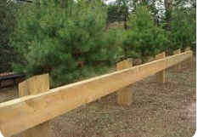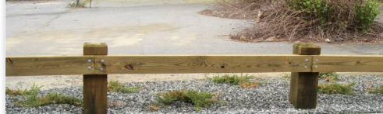

Cohantic Trail Clearing:
Stan and Penny will meet on Oct 19 to do some trail clearing and marking.

There being no further business, the meeting was adjourned at 8:15pm.

Respectfully Submitted,
Penny Newbury, Secretary

