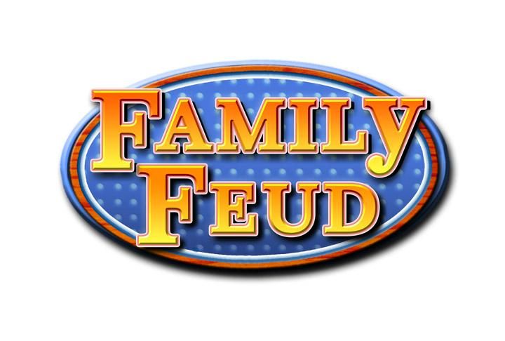



sss
Awareness Week
September 21-25
Tuesday, September 22, 2026, 1:00pm
Check in time 1:00pm & game to begin 1:30pm

Chaplin Senior Center

Come to play or be part of the audience.
From those that want to play, 2 teams of 5 people each,
will be randomly chosen at the time of the event.
The winning team will be awarded prizes.
educational event… THE FALL PREVENTION
In celebration of this very important topic,
FALL PREVENTION
Where:
When:
Call Chaplin Senior Center to Sign up 860-455-1327
please join us for a community wide, fun, interactive,
Sign ups appreciated but not required.
This event is
FREE!

